Task-1:

Code:

Output:

Task-2:

Output:

Task-3:

Code:

Output:

Task-4:

Code:

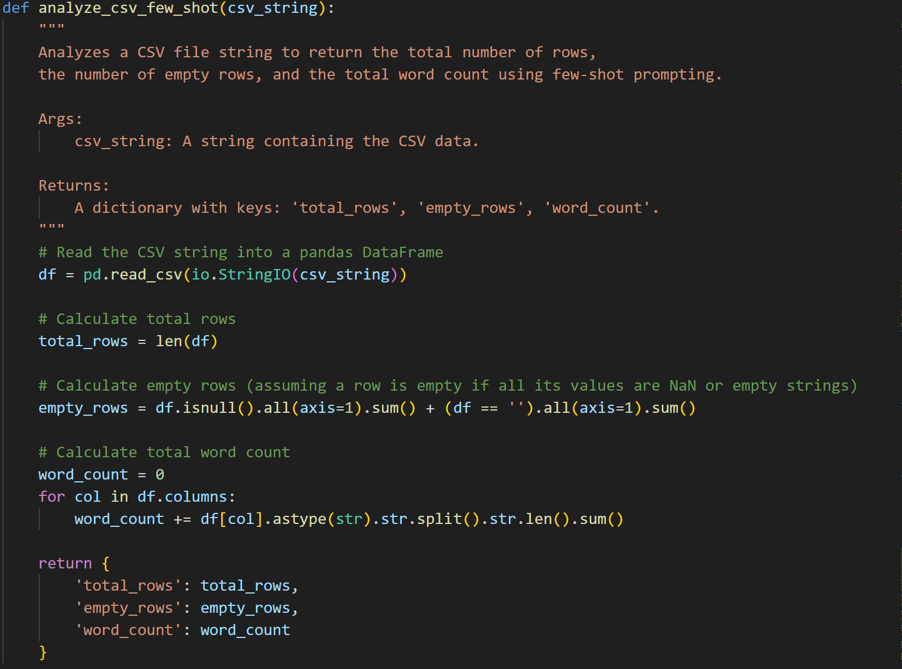

Output:



Task-5:

Code:

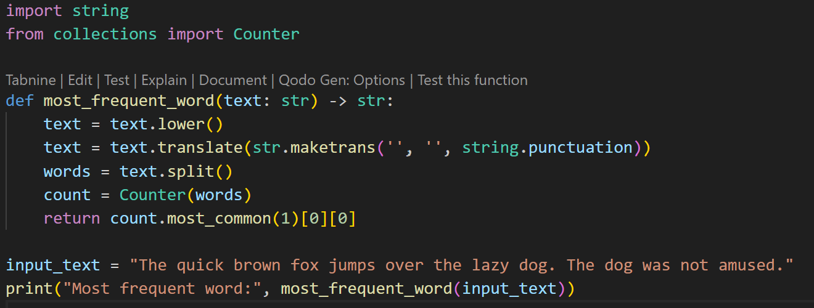

Output:

